

Participant Notebook:  
Learning a language from Videos

Spring 2025

This notebook belongs to: participant 5

Link to Zeeguu: [zeeguu.org](http://zeeguu.org)

**Introduction 3**

Date 3

Goal 3

Your Notes 3

**Session 1 - Video 5**

Date 5

Goal 5

Your Notes 5

**Session 2 - Video + Exercise 6**

Date 6

Goal 6

Your Notes 6

**Session 3 - Article 7**

Date 7

Goal 7

Your Notes 7

**Session 4 - Article + Exercise 8**

Date 8

Goal 8

Your Notes 8

# 

# Introduction

We have developed this notebook to guide your note-taking during the study. The insights we uncover in this study heavily rely on extracting your experience from each session, so feel free to go crazy on the notes!

In the below, we explain each section of the session notes.

## Date

* This should be the date that you complete the session.

## Goal

* This part will instruct you on what your goal is with the session.

## Your Notes

* This is where you put in your notes about the session.
* Aim for at least 3 bullet points for each session.
* We keep an eye on this notebook in case you get stuck. In which case we will reach out to you and help solve any issues you may have.
* At the end of the study we will use your notes to have a discussion about learning languages via videos.
* So what should your notes be about?
  + Something that was frustrating
  + Something that is missing
  + Something you liked
  + Something that surprised you
  + etc.
* Examples
  + *“I really liked that I could translate words while watching the video”*
  + *“Bad: finding a video I liked was too hard”*
  + *“I’m not sure if I completed the goal of this session, but what I actually did was…”*
  + *“Where is the save video button??”*
  + *“Watching the video takes too long because…”*
  + *“I was surprised to find out that…”*
  + *“I didn’t know that I could watch the video in fullscreen.*
  + *“This session was a bit difficult because…”*
  + *“Good: Rewatching the video a few times works a lot better for me*

# Session 1 - Video

## Date

* 25/04

## Goal

* ~~1. Watch a video on Zeeguu that you find interesting and challenging~~
* ~~2. Translate the words in the captions that you don’t understand or find difficult. If you don’t need to translate any words, the video is not challenging enough.~~

## Your Notes

* In general, I think Zeeguu is a fantastic learning tool. From a ‘technical’ point of view, it works smoothly, no bugs, and a great user interface.
* The recommended videos were not entirely tailored to my interests.
* The only thing was that I thought the video I watched was quite a bit above my B1 level - without translating the subtitles, I understood about 30/40%. Because of that I thought it was me being too ‘ambitious’ with my Danish level, so I changed to A2 in the settings. The videos were definitely easier (I could understand around 60%) but I still think they were a bit too challenging for the level. I totally understand that it may just be a lack of video material tailored to that level.
* Is there supposed to be a save video button, like the save article? Can’t see it.
* The option to watch the video in full screen was very clear and visible 👍

# 

# 

# Session 2 - Video + Exercise

## Date

* 02/05/2025

## Goal

* ~~1. Watch a video on Zeeguu that you find interesting and challenging~~
* ~~2. Translate the words in the captions that you don’t understand or find difficult. If you don’t need to translate any words, the video is not challenging enough.~~
* ~~3. Spend 5 minutes trying out the exercises~~

## Your Notes

* I’d like the possibility to click a button that immediately provides the full translation rather having to click the single words. Perhaps giving the possibility to watch the video with simultaneous subtitle in Danish AND English, but only when watching the 2nd time.
* A bit annoying that the video stops every time I click a word.
* With the “Match each word with its translation” exercises, it is not clear to me how many words I actually got right. I would like something that says 3/3, if I got them all right. OR potentially turn all the correct ones green, and the wrong ones in red, just so they visually stand out immediately. I find the three colours (green, light blue, blue) a bit confusing because usually the green colour is associated to a correct answer. The first time I tried, for example, I thought I only got 1 correct answer because only one pair turned green, while the others turned blue.
* I think some of the translations in the exercises are inaccurate, for example the image below:

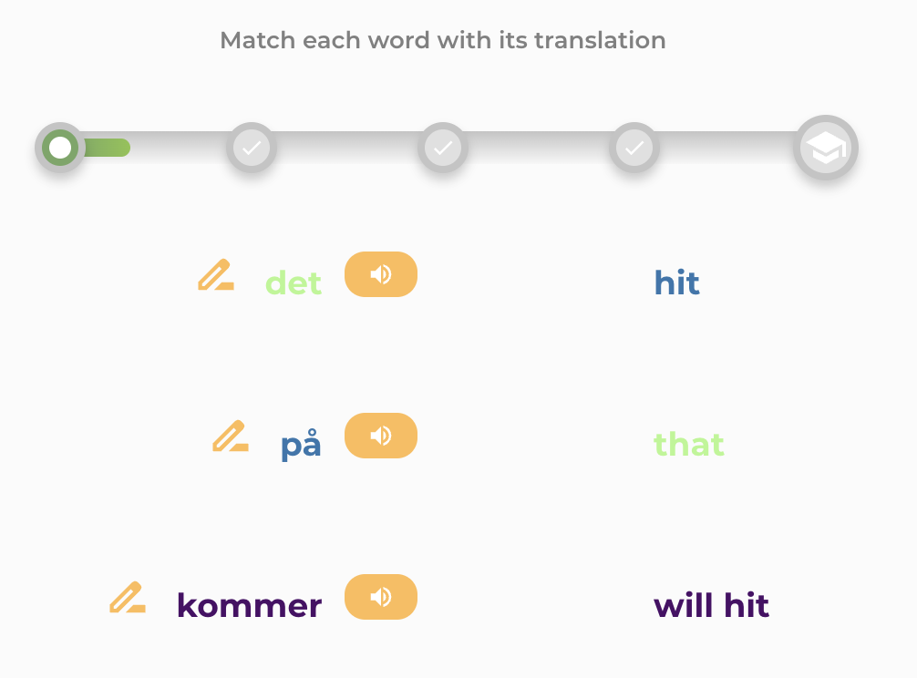

* I am a bit confused why the green bar starts moving towards the next check and then it immediately returns to zero in the next exercise.

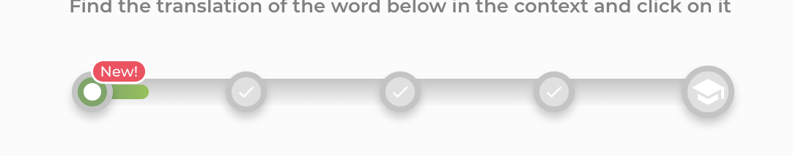

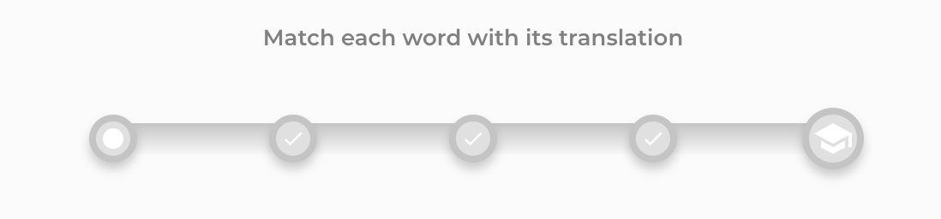

# Session 3 - Article

## Date

* 04/05/2025

## Goal

* ~~1. Read an article on Zeeguu that you find interesting and challenging~~
* ~~2. Translate the words in the article that you don’t understand or find difficult. If you don’t need to translate any words, the article is not challenging enough.~~

## Your Notes

* I had a small issue with accessing the articles. Even though the extension was on, and I was on Chrome browser, I clicked on one of the articles and this message appeared.

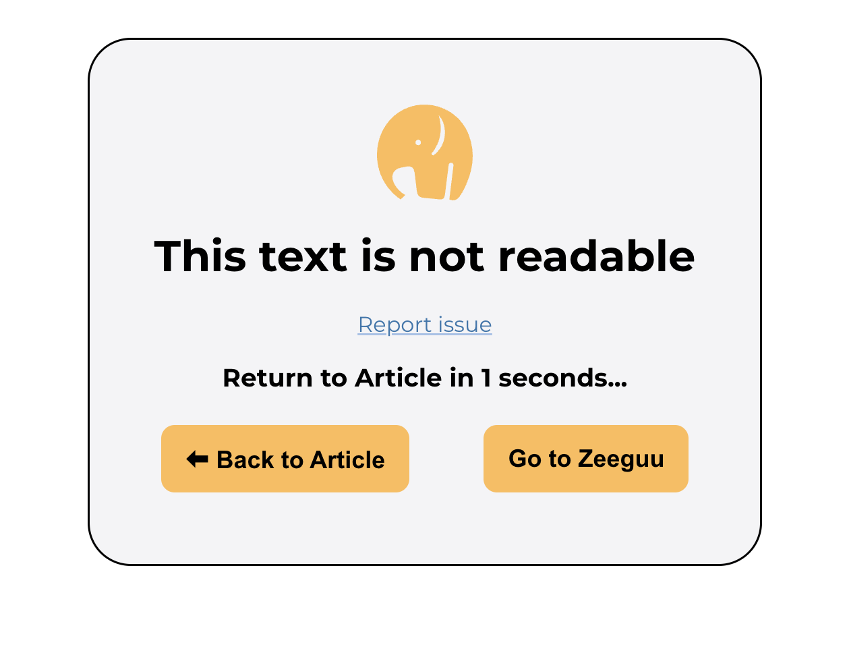

* Apart from that, no other issues. I learn a lot from the articles. I enjoy reading them at my own pace, without feeling rushed.

# Session 4 - Article + Exercise

## Date

* 05/05/2025

## Goal

* ~~1. Read an article on Zeeguu that you find interesting and challenging~~
* ~~2. Translate the words in the article that you don’t understand or find difficult. If you don’t need to translate any words, the article is not challenging enough.~~
* ~~3. Spend 5 minutes doing exercises~~

## Your Notes

* I love the variety of exercises, including filling the gap with words that are only heard via audio.
* Exercises: I love that words are shown in the context of a sentence.
* I was confused with ‘Level 1’ and ‘Level 2’ in the “Words - In Learning” section
* I didn’t understand how to make sure that the exercises included the new words I had just learned from reading an article (i.e. the words in the “Not Yet in study” section). Can I choose the words to include in the exercise, or does it happen randomly?